Exercise
If you haven't already noticed, the program has a bug. When the listbox is empty and the user clicks the listbox, an IndexError is generated in the terminal:

Why does this error happen?
Well, everything starts with the user clicking on the listbox. Clicking the listbox executes the following code:
list1.bind('<<ListboxSelect>>',get_selected_row)
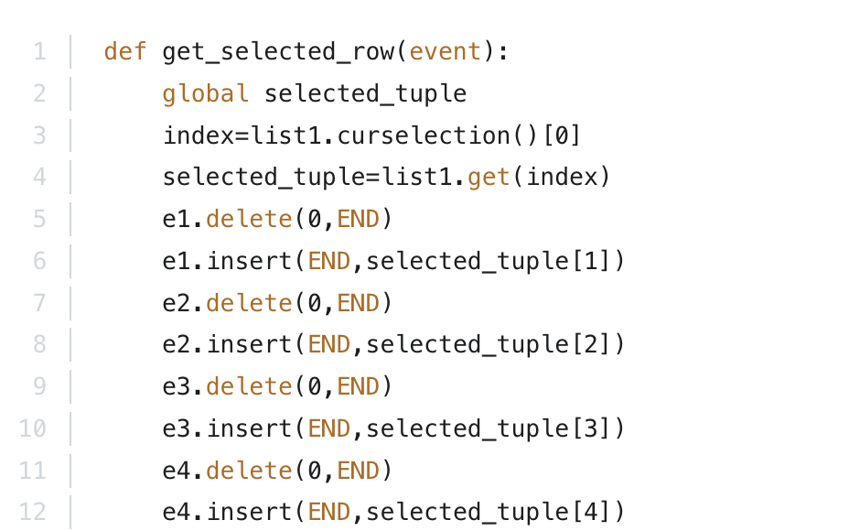
That code calls the get_selected_row function:

Since the listbox is empty, list1.curselection() will be an empty list with no items. Trying to access the first item on the list with [0] in line 3 will throw an error because there is no first item in the list.
Try to fix that bug. The next lecture contains the solution.

